Honor Statement: I certify that all the work on this test is my own. I have not cheated, nor have I acted dishonorably in any way concerning the information on this test.

Signature: ________________________________________ Date: ______________________

AP Physics 2B Midterm

- In the circuit below, the capacitor has been allowed to charge to 5 volts. The switch was then opened. How long will it take the capacitor to discharge to 50% of the original charge?
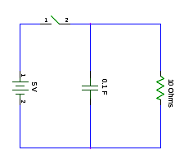
- Find the equivalent inductance of the circuit. What is the current through the 2 H Inductor?
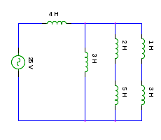

- An object is placed 2 cm from a convex mirror (with a focal length of 3 cm). Determine the distance to the image a) using ray tracing and b) algebraically. Is the image real or virtual?

- An object is placed 3 cm from a convex lens (with a focal length of 1 cm). Determine the distance to the image a) using ray tracing and b) algebraically. Is the image real or virtual?

- A light-ray travels from the air (n=1.001) into a diamond (n =1.9), at a 20 degree angle from the normal. What is the angle that the refracted ray leaves the interface at?

- A 5-volt battery is connected to a 5 Ohm resistor, and a capacitor of unknown value. As the capacitor discharges, you collect the following data. What is the capacitance of the capacitor?

- An electrical quadrapole consists of alternating positve and negative charges arranged at the four corners of a diamond. Draw the electrical field that is produced by an electrical quadripole.

- A capacitor has an electrical field of 100 N/C. A proton is placed between the plates. What is the force that the proton feels? (Magnitude and direction)

- A proton is traveling to the right at an angle of 20 degrees above the x axis. It travels through a uniform, upward magnetic field at a speed of 255 m/s. What is the force that the proton feels?

